**Currents and creation rates model in BTR (thick neutralization). Nov 2013**

Cross-sections considered: -1,0 -1,1 0,1 1,0

The system of balance equations for current densities is solved for each X $∈$ neutralization region:

D- (1)

D0 (2)

D+ (3)

With the bound conditions:

$j_{-}+ j_{0}+ j_{+}=1$ (4)

$j_{-}\left(0\right)=1$ (5)

$j_{0}\left(0\right)= j_{+} \left(0\right)= 0$ (6)

The exact solution is following:

$j_{-}=e^{-Dτ}$*(7)*

$j_{+}=\frac{C}{A}+\frac{B}{A-D}∙ e^{-Dτ}- (\frac{C}{A}+ \frac{B}{A-D})∙ e^{-Aτ}$*(8)*

$j_{0}=1- j_{-}- j_{+}$*(9)*

Here $τ= \int_{0}^{x}{n∙dl}$

$A= σ_{0,1} + σ_{1,0}$ $B= σ_{-1,1}- σ_{0,1}$

$C= σ_{0,1}$ $D= σ_{-1,0} + σ_{-1,1}$

Implementation in code. 3-split model

The D- source big-particle with J0 is traced until it enters the neutralization zone (X = *NeutrXmin*). Within the neutr. zone at each D- trajectory point (after passing $∆x$ *= NeutrStep*) we calculate the exact values for 3 current densities - according to formulae *(7)-(9)*. Next at this very point we emit **2 additional** big-particles - D+ and D0 with respect to the exact creation rates taken from *(2), (3),* integrated along the step, i.e.

- D0 big-particle current at NeutrStep

- D+ big-particle current at NeutrStep

It is easy to check, that when we use precise solution of the system (1-6) the balance of currents (4) is fulfilled, and the balance of rates is kept automatically, although we don’t use it directly:

$\frac{dj_{0}(x)}{dx} = - \frac{dj_{-}(x)}{dx}- \frac{dj_{+}(x)}{dx}$ (10)

The rates balance (10) is illustrated by Fig 1,

where D- drop (green), i.e. $- \frac{dj_{-}(x)}{dx}$, is the exact sum of D0(blue) and D+(red) creation rates.

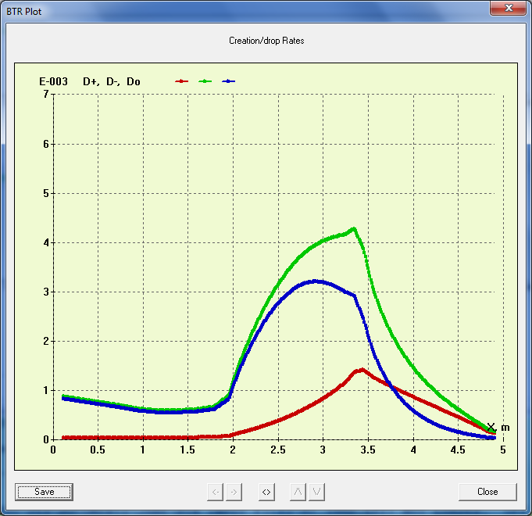 Fig 1.

Although this model uses the precisely calculated values of species intensity and their derivatives along the beam path, it works with several limitations:

* It is good only for small D- trajectory deflections (in MF). The reason is that under 3-split model D+ ions are generated along the D- track (although mainly they are produced by 0,1). Therefore the **angular distribution for D+** is not correct, because they are “produced” by D- instead of D0.
* (presently) The model assumes that each big-particle generated from initial ion (i.e. D0 or D+) carries the current fraction which is not changed next till the particle exits the neutralization area. The problem occurs for very thick gas targets, when the derivative $\frac{dj_{0}(x)}{dx}$ < 0. At present, in this case BTR just stops the particle with negative current. Still the model should be corrected for these situations as well.